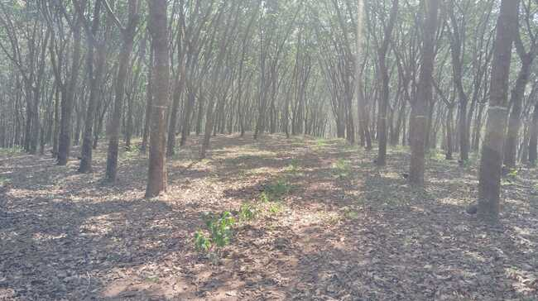

Field Inspection Report of Nettukaltheri & Pozhiyoor in Trivandrum district



Date of visit | 04.01.2025
Members for Visit | 1. Er. Sheik Mohammed Shibl, FSSM Specialist
Members for Visit | 2. Er. Melvin Daniel T.S., LWM Engineer
Members for Visit | 3. Er. Nandhitha R Krishnan, Young Professional

Table of Contents

1. Introduction 3
2. Nettukaltheri - Kallikadu GP - FSTP Project 3
2.1. Background 3
2.2. Nettukaltheri site details 4
2.3. Observations 5
2.4. Recommendations 6
3. Pozhiyoor - Kulathur GP- STP 7
3.1. Background 7
3.2. Pozhiyoor site details 7
3.3. Observations 8
3.4. Recommendations 12

Introduction
The Thiruvananthapuram District Panchayath invited tender for FSTP at Nettukaltheri and STP at Pozhiyoor AVM Canal. The tender was scrutinized by the technical committee of Suchitwa Mission on 19.11.2024 and found ambiguity in the scope of the projects. The committee directed the Suchitwa Mission to conduct site visits and define the scope of each project clearly. Based on that a visit was conducted on 04.01.2025 to both the places. The visit was conducted in the presence of Sri. Arun Joy Assistant Coordinator SWM, District Mission Thiruvananthapuram, Sri. Unnikrishnan, Assistant Engineer, Kallikkadu GP, Smt. Asha Rani, Assistant Engineer, Kulathoor GP, Anu, Village Assistant, Kallikkadu along with the Suchitwa Mission Members. The detailed report for both sites is included in the subsequent chapters.

Nettukaltheri - Kallikadu GP - FSTP Project

Background

The Thiruvananthapuram District Panchayath invited a tender for setting up 65 KLD FSTP at Nettukaltheri jail land, Kallikadu GP, Thiruvananthapuram in the DBOT (Design, Built, Operate & Transfer) model. The technical bid submitted by M/s Primove Infrastructure Development Consultants Pvt. Ltd. in JV with M/s TBF Environmental Solutions Pvt. Ltd., was evaluated in the Technical Committee of Suchitwa Mission conducted on 01.08.2024. The Technical Bid submitted by the agency was not approved by TC and recommended the Local Body (LB) go for a re-tender with a revised scope including collection & conveyance of septage and desludging as the LB’s scope of work, using their vehicle or licensed private desludging vehicle.
In the re-tender, the project was revised as 65 KLD STP cum FSTP project. The TC suggested changing the tender title to "FSTP alone", but it remains the same. The bids were submitted by M/s Ionex Envirotech Pvt. Ltd. and M/s Primove Infrastructure Development Consultants Pvt. Ltd., and were evaluated in TC conducted on 19.11.2024. Among the two agencies, only one agency has quoted for the provision of the sewage channel and its associated treatment schemes along with the FSTP. The other considered the tender as a standalone FSTP and gave the technology options for septage treatment. Since there is confusion in the project's scope, a transparent evaluation of the received bids cannot be conducted. Hence the TC advised Suchitwa Mission to conduct a site visit along with the local body representatives and define the scope of the project based on the site conditions. Thus, Suchitwa Mission with the help of Wash Institute conducted a site visit and the scope of the project has been defined.

Nettukaltheri site details
The site is located on the outskirts of the panchayat, with limited road access that would need to be developed if the project is implemented. The Kallikadu GP is the LB with a population of nearly 18,000 around 4 km circumference. A land area of 1 acre under the ownership of Jail Authority is allotted for the wastewater treatment plant. The land allotted for FSTP is raised land and now it is a rubber plantation. The proposed land is situated in Thevancode Ward with coordinates as 8°33'19.2"N 77°07'56.1"E

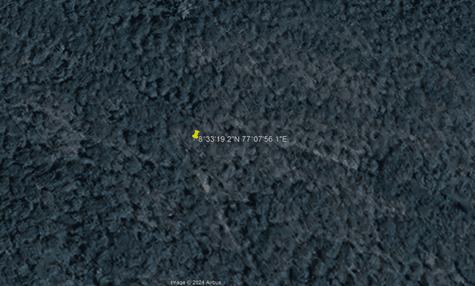
Fig.1 Location of site
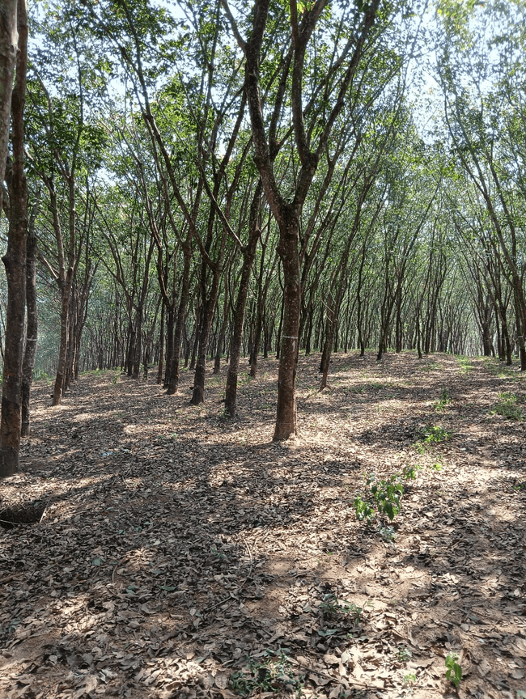 | 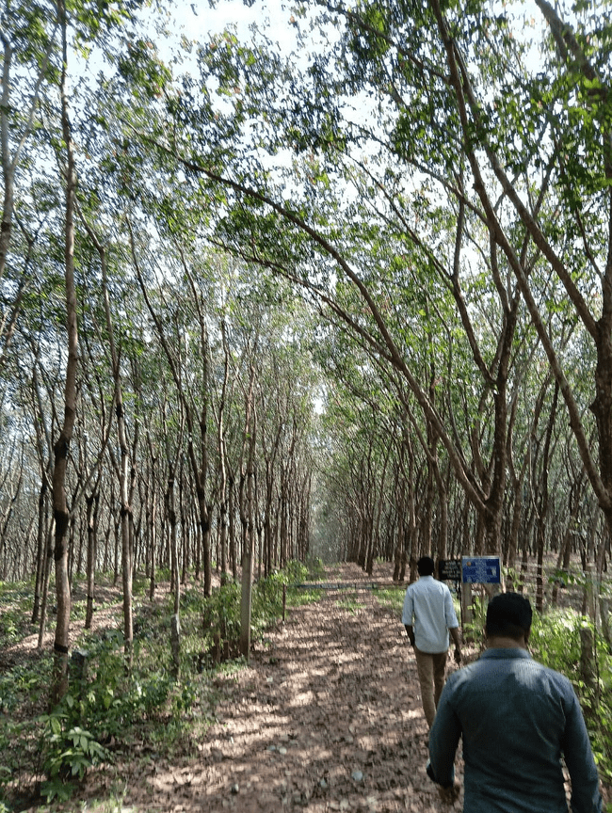
Fig.2 Proposed land

Observations
- The Panchayath Committee members who joined the site visit were comparing this project with the Vilappilsala waste management facility and expressed their strong opposition to admitting the wastewater from other LBs and will not allow clustering. They were willing to set up a treatment plant to manage their wastewater. But being a minus Panchayath, funding will be an issue, and implementation of a project without clustering is nearly impossible.
- The land allotted for FSTP seems suitable for the construction of the FSTP except for some congestion in the access road to the plot. A particular portion of the access road is congested with a width of below 3m and needs to be developed by the LB along with the implementation of the project. There is an approximate distance of 4 km from the main road to the proposed site with residences on either side of this road. Considering the possible total road width, a 3000-litre capacity suction truck will be suitable.
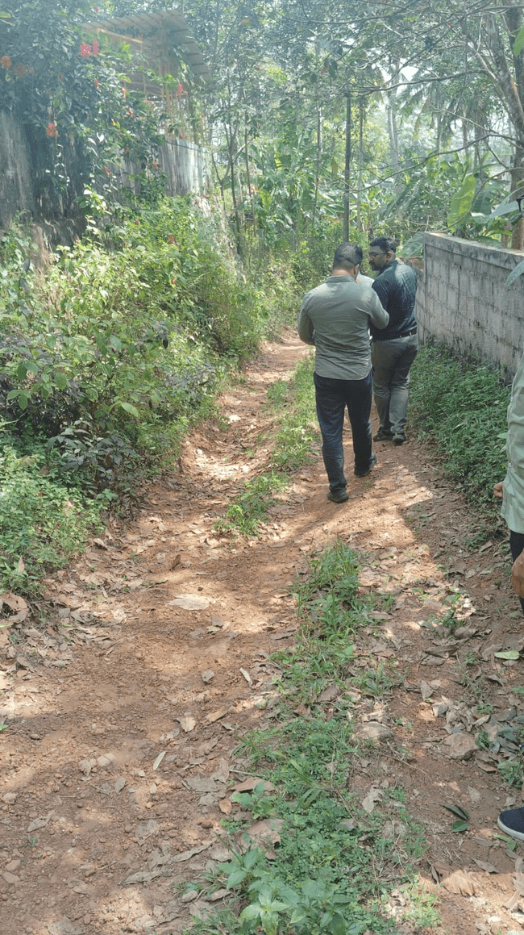
Fig.3 Congested access road of width less than 3 m

Recommendations
Considering the strong opposition from the Panchayath Committee, undertaking the liquid waste management facility on the site may cause administrative and technical challenges. Even considering the site suitability and requirements of such a project, the project needs to be taken up for further procedures. The following recommendations may be considered
- The site is suitable for constructing standalone FSTP. No sewer line to the plant is possible in the near future.
- The road width of the proposed land is narrow and needs development. Considering the maximum width, a desludging truck of 3000L capacity can be utilized in the plant.
- The plant may have the facility to treat the hotel wastewater as a separate channel if there is a requirement. The necessity needs to be finalized based on the availability of such wastewater around the proposed plant site.
- The project can be either tendered for the DBOT model or DPR Preparation. The scope of the project shall be limited to standalone FSTP. An additional facility for treating hostel wastewater ( through trucks) can be added if any requirement exists there.
- The clustering details for the above project need to be finalised. A meeting to be called with the neighbouring panchayaths
- IEC activities need to be arranged to curb the public agitation against the FSTP clustering approach. The necessity of FSTP projects also to be given to the participating LBs.

Pozhiyoor - Kulathur GP- STP

Background

The Thiruvananthapuram District Panchayath invited a tender for setting up three 10 KLD FSTPs and a 100 KLD STP at Pozhiyoor village, Thiruvananthapuram in the DBOT (Design, Built, Operate & Transfer) model. The technical bid submitted by M/s Sainath Envirotech was evaluated under the Technical Committee of Suchitwa Mission conducted on 16.09.2023. The project scope and capacity were confusing and the evaluation was not possible. In the re-tender, the project was revised as 350 KLD STP cum FSTP for the coastal village at Pozhiyoor (AVM canal), Thiruvananthapuram. The bids were submitted by M/s Pollucon Technologies and M/s Ionex Envirotech Pvt Ltd and were evaluated in TC conducted on 19.11.2024. Since the project dimensions are still not framed, the TC advised Suchitwa Mission to conduct a site visit along with the local body representatives and define the scope of the project based on the site conditions. Thus, Suchitwa Mission with the help of Wash Institute conducted a site visit and the scope of the project can be defined.

Pozhiyoor site details
Pozhiyoor is a coastal region of Kulathoor grama panchayat, where the proposed site is inside a stadium and near the backwater canal called AVM canal. The wastewater from the nagar in the nearby area which currently merges into the backwater needs to be channelised and diverted to the proposed site for treatment. The public is bathing in the place where the used water gets merged to the backwater and they also complain of mosquito issues. The existing scenario in the nearby Nagar and the proposed site are shown in the figure below. The proposed land is situated in Pozhiyoor in the Udaya stadium with coordinates as 8°18'11.8"N 77°05'10.1"E

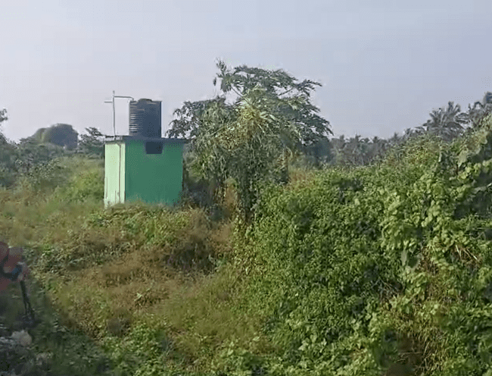
Fig.4 Proposed land
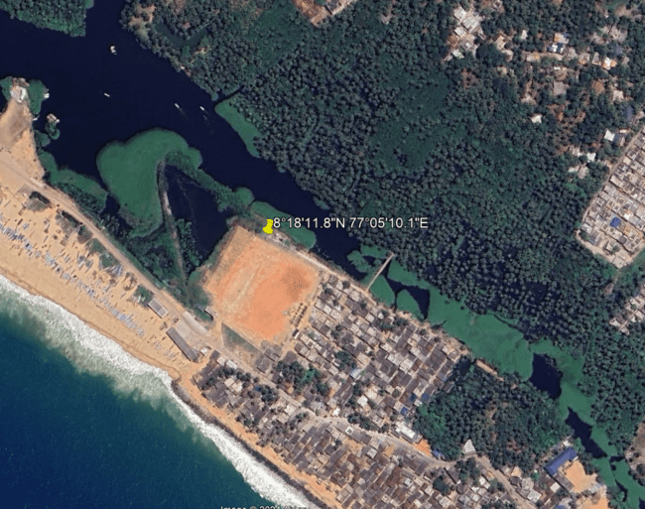
Fig. 5 Location of site

Observations
- Currently, the wastewater (blackwater and greywater) from these Nagar is disposed to the AVM canal through a drain system under gravity. Some of the households have their soakpit facility. The drain is filled with solid waste like toys, utensils, food waste, etc, thereby clogging the drain and causing a foul smell from the drain which shows the improper disposal of wastewater into the drain. This drain is in deteriorated condition, with the same level as the canal leading to the backflow of water from the canal to the drain making the premises filthy and unhygienic. The residents reported that some maintenance of the canal (increasing depth) under some Central schemes is in progress and under site visit, the drains were filled with C&D waste.
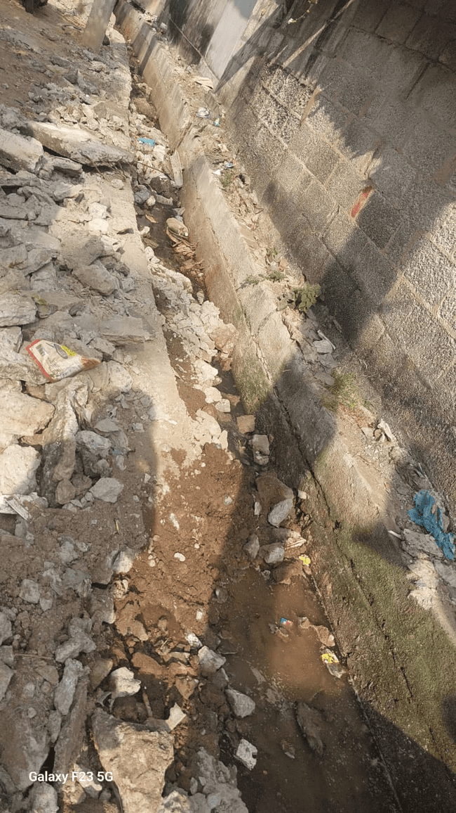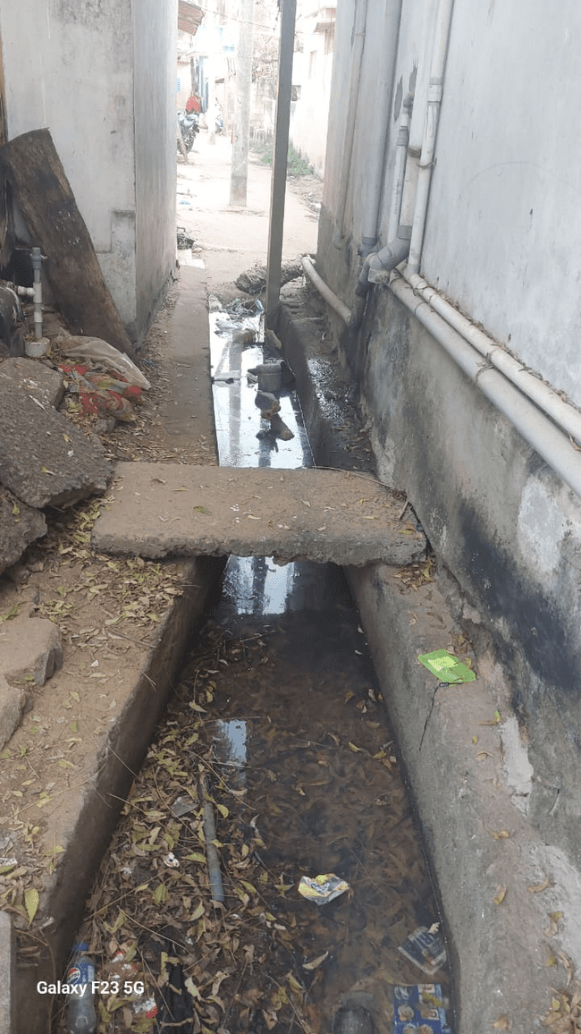
Fig. 6 Current scenario of drain carrying wastewater from houses
- The proposed site for the treatment plant has space constraints and it is on the banks of the AVM canal. The minimum distance criteria prescribed by the Kerala State Pollution Control Board (KSPCB) cannot be met on this site. But considering the unexceptional requirement of the treatment plant, special permission shall be sought from the KSPCB.
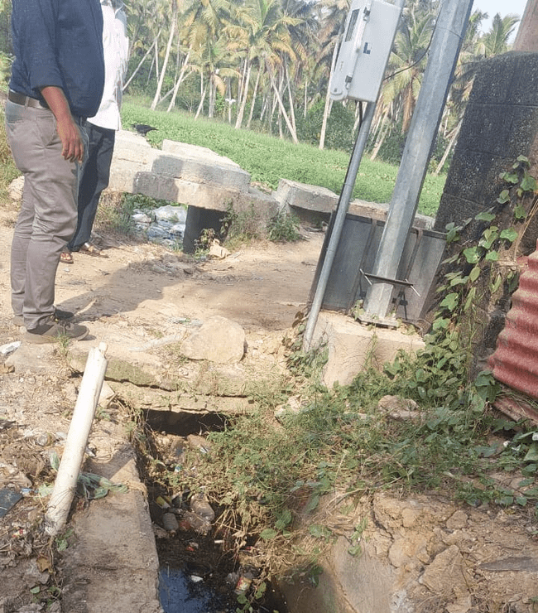
Fig. 7 Drain outlet to AVM canal
- The drain outlet was directed to the AVM canal, which led to the sea. The residents were bathing at a point about 50 m from the downstream point of this outlet. The residents added about the freshwater scarcity and higher dependency on this canal for daily needs. This leads to various health issues for the residents. The canal was completely filled with water hyacinth showing the high eutrophication in the canal caused due to the high nutrient content by waste disposal.
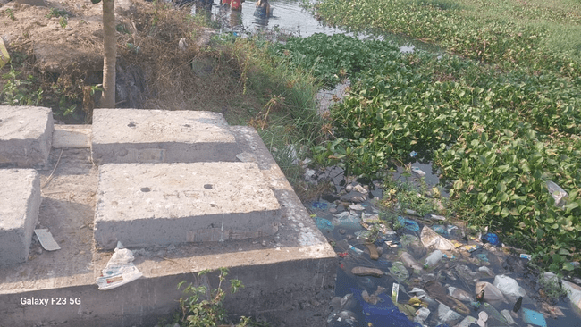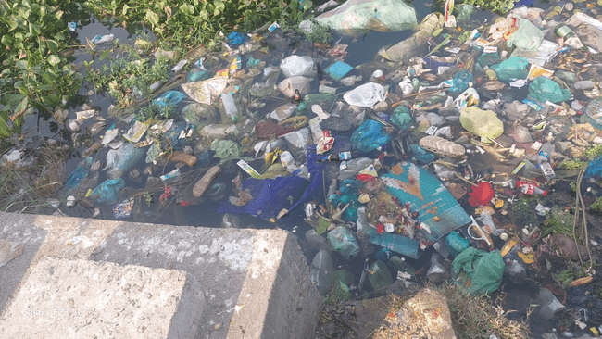
Fig.8 Residents bathing in polluted AVM canal/ Outlet of the drain into the canal with waste

- A proper solid waste management facility is necessary in the area. The plastics and other wastes were being burned at the proposed site. The residents should be given proper awareness about the necessity of waste management (both solid and liquid waste management) and the harmful effects of burning non-bio solid wastes.
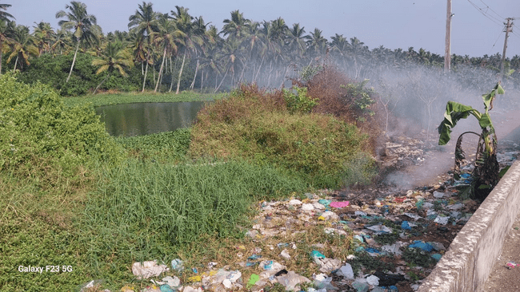
Fig.9 Burning solid waste in the proposed site/ Proximity of AVM canal with site
- If the drain is used for I&D purposes to convey the wastewater from the houses to the treatment plant, certain modifications and retrofitting works of the drain will be necessary. The drains are open type, which needs to be converted to closed type by covering with slabs. The measures to increase the level of the drain to the canal should be adopted, to prevent the backflow of canal water into the drain and thereby ensure the proper working of the system. The topography of the nearby Nagar area needs to be studied for proposing the conveyance of the used water to the treatment facility.
- The Assistant Engineer, who joined the site visit from Kulathoor GP reported the site is very common to seawater attacks like swell surge waves. During this phenomenon, the sea water rises to the land level engulfing these sites and damaging the infrastructure. A building (bus stand) in the near vicinity of 100 m from the proposed site was seen tilted by this phenomenon. Thus, the construction of the treatment plant should be designed based on these specific site conditions to cater to seawater intrusion, seawater attacks, flooding conditions, and proximity to sea line and canal water levels.

Recommendations
The necessity of a treatment facility at the site is inevitable considering the WASH aspects. A detailed study of the area is required to assess the quantum of area, quantity of wastewater, and networking. Following are the recommendations based on the site visit.
- The project shall be implemented as DPR preparation and Execution, instead of DBOT model.
- The site demands a proper Sewage Treatment Plant for the treatment of both grey and black water generated.
- The LB shall entrust an agency to prepare the Detailed project report (DPR). The agency shall be able to submit the DPR within 2 months of award of the work.
- The number of households connecting to the STP and the remaining households shall be properly assessed.
- The land proposed for constructing the STP is near to the bank of the AVM canal. LB may seek special permission from PCB to obtain the consent.
- As mentioned earlier, the site is prone to natural seawater intrusions and waves. So the possibility of constructing elevated STP needs to be discussed with the agency
- The area has a Take a Break facility, stadium, fish market, and some commercial buildings. The wastewater from these facilities can be transported to the STP employing a Truck or sewer. For treating such wastes additional components need to be added to the plant. LB has to confirm on this approach
- The treated water shall be in the standards prescribed by the PCB for discharging into the drains. A portion of treated water may be reused in the Take a Break and the stadium.
- The plant shall be in the nature of a biopark to attract tourists.

